

MINISTRY OF EDUCATION AND TRAINING

**UNIVERSITY OF ECONOMICS AND FINANCE**

**COURSE REPORT**

**Web Application Development**

**TOPIC**

**TRAVEL WEBSITE**

Department: **Information technology**

**Lecturers**: Hoang Van Hieu

**Student code 1**: 215050683 **Student name 1**: Bui Tran Trung Nhan

**Student code 2:** 195050974 **Student 2's name:** Le Tan Dat

**Class:** **231.ITE1265E.B034E**

| Bui Tran Trung Nhan | 100% |
| --- | --- |
| Le Tan Dat | 100% |

Table of contents

SUMMARY 3

Chapter 1: Overview of the research field. 3

Chapter 2: System design analysis 3

Chapter 3: Building and testing the system. 4

Chapter 4: Conclusion and development direction of the topic. 4

Overview of the research field 4

1.1 Reason for choosing the topic 4

1.2 Introduction to the problem and some related research 5

System analysis and design 8

Analyze and design websites to develop desktop applications 8

Structure-oriented design analysis method 11

Database for travel websites 12

Procedures for registration, review, acceptance, and liquidation of lecturers' topics: 13

Analyze the current situation 14

Advantage: 14

Defect: 14

Determine requirements 15

+ database: 16

Unreasonable requests: 16

System design 18

Build and test the system 21

Program interface 21

Conclusion and development direction of the topic. 24

Conclusion 24

Development direction of the topic 25

# SUMMARY

## Chapter 1: Overview of the research field.

Tourism website is one of the important tasks for businesses operating in the tourism field. Efficiency in managing tour information, sales transactions and product information is critical to website success. In today's digital age, building and operating a tourism website has become an indispensable part to help tourism businesses improve management efficiency and optimize business processes.

This report will introduce how to manage a tourism website through building and using an online sales platform. This is a platform that helps travel websites organize and track information about travel products, customers, orders, and sales transactions easily and effectively. By using the website's user-friendly and intuitive interface, users can conveniently perform management tasks, helping to save time and optimize workflow.

We will start by learning about the goals and benefits of using a sales website in managing a travel website, then learn about the important features of the website, along with instructions on how to implement and use. In addition, we will also discuss common challenges and how to solve them to ensure that the website truly plays an important role in effective travel website management.

If you run a travel website or are interested in optimizing business processes in the travel industry, this report will provide you with valuable information and useful ideas to improve your operations. your business, improve your website management performance.

## Chapter 2: System design analysis

In this chapter, the team will present the theoretical basis for desktop website development and database design as well as data logic. From evaluation and analysis, the team builds a business model of the system using data flow diagrams, builds link models, designs databases, physical data tables, and designs input interfaces. data.

## Chapter 3: Building and testing the system.

In this chapter, the team presents the tools and technology for building the system. Install and test the system to evaluate the effectiveness of the program.

## Chapter 4: Conclusion and development direction of the topic.

In this chapter, the team wants to create a website that includes activities in a tourism website effectively. Through the research and development process, the team has achieved a number of important achievements. Design and develop website interface based on user-friendly principles, helping store staff and customers easily use the website without the need for in-depth professional knowledge. Database integration allows product, customer and transaction information to be securely stored and easily retrieved. The team has performed testing and bug fixes to ensure website stability and reliability. Enhance security for important store and customer data. Continuously check and update the website to ensure stability and respond quickly to technical issues.

# Overview of the research field

## 1.1 Reason for choosing the topic

Today, in the context of an increasingly competitive and developing tourism market, managing a tourism website becomes complex and requires efficiency, especially in tracking and managing tour information. travel, customers and transactions. To meet these challenges, I decided to choose the topic "Managing tourism websites through digital technology" for my development project. In this article, I will present some important reasons why I chose this topic.

First, the travel website market is becoming increasingly important and diverse. With the strong development of the tourism industry, managing an effective tourism website is no longer a simple task. To compete and succeed in this industry, businesses need an effective management tool that helps them optimally track tour, transaction and customer information. Travel management websites have the ability to meet these requirements and help tourism businesses advance in competition.

Second, for the tourism industry, customization and specificity are important factors. Each travel website may have special requirements regarding tour management, destinations, service types and schedules. This requires a management website that can be customized to meet these specific requirements. Choosing this topic is an opportunity for me to demonstrate sophistication and flexibility in website design.

Third, this project is not only an opportunity to learn and develop personal skills but also an opportunity to apply theoretical knowledge into practice. I can practice programming skills, build user-friendly interfaces, databases, and integrate features effectively. This is a great opportunity to master web programming knowledge and skills.

Fourth, the group realized the commercial potential of this topic. After the website is completed and optimized, it can become a commercial product for related businesses. This opens up future business and profit opportunities.

Fifth, for the team, this project posed a worthwhile technical challenge. Building a travel website requires the ability to integrate databases, process transactions and interact with users effectively. This is an opportunity to challenge and improve the individual technical abilities of each person in the group.

Finally, choosing the topic "travel website" means participating in a real project with wide application. In short, choosing the above topic not only has practical significance but also brings many benefits for personal development and future business opportunities. This is a promising project and the team is fully committed to its successful completion.

## 1.2 Introduction to the problem and some related research

**1.2.1 Introducing the problem**

Website development is an important subject for lecturers and students majoring in information technology in general and website technology in particular. Promote the improvement of technological and professional qualifications of lecturers and students in the 4.0 era. This topic contributes to diversifying the technology field. Therefore, UEF lecturers have introduced topics in the field of websites for students to develop and understand more.

**1.2.2 Related studies**

Currently, websites are increasing in quantity and quality. Besides, the field of Information Technology is developing very strongly, creating favorable conditions for many units, agencies, and schools to develop programs and systems. During the project implementation process, the team surveyed and found that currently there are many agencies and organizations that have been building systems.

**1.2.3 Challenges in the problem**

In recent years, website development software has developed strongly. The software is built by employees working at schools, agencies, and organizations. Each software is acquired by agencies and organizations from outside software companies. In general, there are still many difficulties during construction and operation. Each unit has a different management style leading to uniformity and the introduction of different optimal software.

For manual science and technology software management units that use records and tables stored on computers, when building software, they must face the problem of how to synchronize and digitize. All data to date is included in the system.

The fact that software can change over the years leads to a loss of knowledge about the software, which can lead to barriers in applying management software to work.

**1.3 Objectives, topics, scope**

**1.3.1 Research objectives**

The main goal of this project is to develop a tourism website that meets the needs of the tourism industry, helps manage operations effectively and enhances customer experience.

**1.3.2 Research subjects**

The research subjects are tourists, specifically international tourists, domestic tourists, group tourists (tours), individual tourists, and family tourists. This study group includes people who participate in tourism activities and use tourism services.

**1.3.3 Scope of research**

The scope of the study is everyone involved in the topic, including business owners, employees, customers, suppliers, and other stakeholders.

**1.4 Research content and methods**

**1.4.1 Research content**

Research content is user interface design, database management, customer interaction including concepts, principles, models and effective management methods. Analyze the current state of clothing store operations, including issues of merchandise management, employees, customers, revenue, costs and profits. Design and build tourism websites, including functions: login, registration, search, view product information, ordering, payment, order management, account management. Evaluating the effectiveness of a fashion travel website includes criteria such as: features, interface, speed, safety, ease of use and customer satisfaction. Conclusion and recommendations to improve tourism website and improve management efficiency.

**1.4.2 Research methods**

Determine the goal, audience, scope and meaning of the topic. Overview of theory and practice related to clothing store management, including concepts, principles, models and effective management methods, web applications in building sales websites. Analyze the needs and requirements of users, customers and store owners, determine the functions and elements needed in a sales website. Design interface, database and sales website system architecture, using tools such as C#, HTML, CSS, JavaScript, PHP, SQL Server. Program and realize the sales website according to the given design, check and fix errors. Evaluate the effectiveness, features and user satisfaction of the sales website, comparing it with other websites in the same field. Conclusion and make suggestions to improve the sales website.

**1.5 Topic contributions**

After implementing the project, the team successfully built a basic tourism website, updating information quickly and promptly, including:

**For customers:**

**Convenient shopping experience:** The website helps customers easily search for products, view detailed information about the product such as places to visit, accommodation, price and the ability to interact with the product before purchasing.

**Convenient payment:** Customers can conveniently pay via the website, helping to save time and increase shopping experience.

**For employees:**

**Tour management:** The website helps employees make transactions, create invoices and manage order information quickly.

**Customer management:** Employees can view information about customers, their shopping history, and customize services based on customer data.

**Invoice and invoice details:**

**Bill:** Website creates and manages shopping invoices, allowing to store information about orders, number of participants, price, and purchase date.

The project's contribution to customers and employees is to enhance the shopping experience and store management, helping them save time and effort. Invoices play an important role in recording and managing purchase and order information, helping you have a detailed view of your business activities.

# System analysis and design

## Analyze and design tourism websites.

**Set goals:**

Clearly define the goals of the travel website. This includes determining the functions, features and benefits that the website must provide to users.

**Determine requirements:**

Collect requirements from users, customers and stakeholders. This requirement includes functionality, user interface, performance, and database system.

**Define user interface:**

Design user interface based on requirements. This includes drawing the user interface, defining page structure, layout, colors, and other design elements.

**Define database:**

If your website requires data storage, you need to identify the necessary databases, tables, and data relationships. This helps determine how data is stored and retrieved within the website.

**Architectural design:**

Determine the overall architecture of the website, including main components such as control layer, interface layer, database and network connection (if necessary).

**Technology options:**

Choose appropriate technology to develop website. This includes programming languages, frameworks, libraries, and development tools.

**Database design:**

Design the database based on requirements and architecture. This includes defining tables, data fields, constraints, and data rules.

**Application logic design:**

Determine processing logic for the website. This includes building the website's functions, methods and workflows.

**Design check:**

Test and evaluate the design to ensure that it meets the requirements and goals of the website.

**Prepare design documents:**

Create detailed design documents to support the development process. Includes documentation of the database, user interface, application logic, and architecture.

**Start developing:**

Once the design has been approved, you can begin the process of developing a travel website based on the design.

Approaches to website development and desktop application development

**Determine requirements:**

First, clearly identify the requirements of the travel website you want to develop. This includes defining functionality, user interface, performance and technical requirements.

**Zoning:**

Create a project plan detailing the phases, timing, and resources required for the development project.

**Select Programming Tools and Languages:**

Choose the programming language and development environment that is right for your project. Popular languages ​​and tools include HTML, CSS, JavaScript, Python, PHP, and Ruby on Rails.

**User interface (UI) design:**

The website's user interface design ensures ease of use and aesthetics. Use interface design tools.

**Website development:**

Start coding and developing the website based on the defined requirements and design. Follow good programming principles and use knowledge of project structure.

**Experiment:**

Perform website audits to identify and fix errors and problems. Integration testing, UI testing, and performance testing.

**Optimization and tweaking:**

Optimize performance and tune the website to ensure it runs smoothly and meets requirements.

**Deployment:**

Prepare the website for deployment and installation on the end user's server. Make sure the implementation process goes smoothly.

**Support and maintenance:**

Provide support to end users and maintain the website by updating and fixing errors as necessary.

**Development steps of tourism website**

Determine requirements

Planning

Choose programming tools and languages

User interface (UI) design

Website development.

Check

Optimization and fine-tuning

Deployment

Support and maintenance.

## Structure-oriented design analysis method

**Professional survey and collection of related documents and records:**

Survey the business process of the travel website and collect related documents such as sales reports, product information, customer data, and customer requests.

**Build a context diagram:**

Build a context diagram to describe the main interactions between users and the clothing website system, including customers, employees and administrators.

**List the documents used for the system:**

List and manage related documents such as system requirements documents, user interface design documents, and database documents.

**Build professional functions:**

Build the main functions of the website such as product search, ordering, payment, tour management, and order tracking.

**Draw a data flow diagram by level:**

Draw a data flow diagram (DFD) to depict information flows between system components. This includes different levels from overview to detail.

**Determine the program's functional diagram:**

Identify the main functions of the program and how they relate to each other. For example, the ordering function will link with the inventory management function and the payment function.

**Designing interfaces:**

Design the user interface for the website, ensuring friendliness and ease of use. Includes main pages such as home page, product page, cart page, and checkout page.

## Database for travel websites

**Data:**

Data includes meaningful, recordable events such as product information, customer information, orders, and transactions.

**Database:**

A database is a collection of related data, stored on a server, for many users and organized according to a certain model.

**Relational database:**

Is a set of relationships that change over time. When a relationship in a database changes, the number of its records also changes, and the contents of some sections also change. This accurately reflects the business objects.

**How to create a relationship:**

To create relationships in a relational database, we need the following components:

Relationship name.

Associate data with those relationships.

Determine the keys of the relations (if any).

**Data binding:**

To ensure proper data storage for the object, there can be 3 most basic types of constraints:

Type constraints.

Computational constraints.

Logical constraints.

**Math operations on relational databases:**

The database changes frequently thanks to the following operations:

**Insert:** Adds a new record to a given relation.

**Delete:** Remove any records from any set.

**Change (Update):** Modify the contents of any record in any set.

By applying a structure-driven analysis and design approach, we can build an effective travel website that fully meets business and technical requirements.

Describe the tourism website business process

Procedures for registration, approval, acceptance and liquidation of tourism website projects:

**With permission from department head:**

The tourism website project development team needs approval from the department head to ensure the project is built clearly and in detail.

**Process modeling:**

The team modeled the travel website's business process, including collecting information and analyzing requests from stakeholders.

**Assign team leader:**

The group assigns one person to be the group leader to represent the topic and submit it for review. The team leader is primarily responsible for coordinating with members and ensuring the project proceeds according to plan.

**Research and select necessary data:**

After submitting the project, the team researches the parties involved in the topic and selects the necessary data for the project such as the database and the process of implementing website functions.

## Procedures for registration, review, acceptance, and liquidation of lecturers' topics:

**Detailed explanation of content:**

After obtaining the list of topics, the lecturer will explain in detail what needs to be done to suit the requirements of the subject.

**Topic completion and instructor support:**

Students will be given time to complete the topic. If you have difficulty researching a topic, students can ask the instructor to receive the necessary support.

**Track progress:**

After about 1 to 2 weeks, the lecturer will ask the groups about their progress in completing the topic as well as the difficulties encountered.

**Topic submission and scoring:**

The instructor will give a specific date for groups to submit their topics and source code. The instructor will then grade based on the quality and completion of the sections completed.

This process ensures that the tourism website development project is carried out in an organized manner and fully meets the requirements from both the school and the business.

## Analyze the current situation

## Advantage:

**Web application development technology:**

Using website development technologies helps create a user-friendly, modern and easy-to-use interface. The travel website system can integrate with databases such as SQL Server to store and process information about tours, customers, employees, revenue, and discounts.

**Diverse features:**

Travel websites can support functions such as logging in, registering, searching, viewing tour information, ordering, payment, order management, and account management. Website can operate on many different devices such as computers, phones, tablets and ensures high safety.

**New technology application:**

New technologies such as artificial intelligence, machine learning and data analytics can be applied to classify and recommend products that suit customers' preferences, needs and budgets. In addition, combining with social networks helps spread the clothing store's brand.

## Defect:

**Infrastructure requirements:**

The travel website system needs a stable internet connection to operate. If there are problems with electricity, network or hardware, the website will be affected, disrupting sales and management.

**Security and risks:**

Websites can be attacked by hackers, viruses or other malicious websites, causing loss or disclosure of data information. Therefore, strong security measures are needed to protect data.

**Training requirements:**

Employees need to be trained to become familiar with the functions and features of the website, otherwise it will easily cause errors during use.

**Ability to meet:**

The website system may not be suitable for some different types of businesses or may not meet the changing needs of the market and customers. Therefore, it is necessary to be flexible and regularly updated to keep up with trends.

## Determine requirements

**Require function:**

+ Interface for management:

- Must have a friendly, easy-to-use interface for store staff.

- Management interface allows adding, editing, and deleting information.

- The interface must display a list of products with detailed product information

- Must have product search function and view product details.

- The management interface needs to allow adding, editing, and deleting customer information.

- Must have the function to create sales invoices and created invoices.

- Must have payment integration to process payments from customers.

- The interface must allow tracking the number of available products.

- Display products, prices and shopping information clearly and attractively.

## + database:

- Need to design and implement a database to store information about products, customers, transactions and other data.

- Data must be stored and retrieved securely and reliably.

+ Payment integration and customization:

- Need to integrate payment gateway or provide online payment processing method when customers buy products.

- Allows customization of the application to meet the specific requirements of the travel website.

+ transaction:

- Must have transaction and transaction status features, allowing creation of sales invoices and order information.

+ Interaction with customers:

- Provide customer interaction features such as customer care and promotions.

+ staff:

- Allow employee information including name, position, employee code and work schedule.

+ customers:

- Store customer information including name, address, phone number and email.

- Allows you to easily search and view customer information.

- Create promotions and discounts specifically for customers.

+ Integrating artificial intelligence:

- Use artificial intelligence to make product suggestions, predict customer needs and optimize strategy.

## Unreasonable requests:

Stability and security:

**Stable operation:** The website system must operate stably and without errors.

**Data protection:** Customer and product data must be securely protected.

**User authentication:** Ensure security and accurate user authentication.

Ability of extension:

**New features added:** The website must be scalable to add new features and functions over time.

**Other system integration:** Ability to integrate with other systems if necessary.

Efficiency:

**Quick response:** The interface must respond quickly, without causing freezes or lag.

**Process data quickly:** Process data quickly, especially when managing large numbers of products and customers.

Cross-platform support:

**Works on many devices:** The website must work well on many devices such as computers, phones, tablets, and on many different operating systems.

User interface (UI):

**Friendly, easy to use:** The user interface must be friendly and easy to use.

**Multi-language support:** Multiple languages ​​must be supported if your store serves customers from multiple countries.

Attractive design:

**Promote interaction:** The interface must be designed to be attractive and promote user interaction.

Maintenance and source code:

**Clear source code:** Source code must be written clearly, easily understood and have instructions for use.

**Update and maintenance:** Must be able to easily update and maintain the application.

Redundancy, backup:

**Backup solution:** It is necessary to provide a backup solution to ensure data is not lost.

**Back up regularly:** Need to be able to back up data regularly.

Compatible with many types of stores:

**Flexible customization:** The system must be customizable to suit many different types of travel websites.

Network connection support:

**Operation in network environment:** Must be able to operate well in a network environment, especially when the store expands or has many points of sale.

These non-functional requirements ensure that the travel website will operate stably, securely and efficiently, while also being able to adapt to many situations and ensure user satisfaction.

## System design

System design in a tourism website project is an important part to ensure the system operates effectively and is scalable. Below are some system design requirements and notes:

1. Application architecture:

- Define the general architecture of the application, including classes, modules, and database.

2. Database:

- Design a database to store information about products, customers, orders and related data.

- Use SQL Server database system

3. User interface:

- User interface design provides a friendly, easy-to-use experience for end users.

- Make sure the interface can adapt to many screen sizes.4. Event handling:

4. Application logic layer:

-Identify user events such as mouse clicks, button presses, data entries and design handling for them.

-Use events to connect the interface to application logic.

5. Application logic layer:

- Design logic layers to handle functions such as products, customers, and order processing.

- Ensure separation between user interface and website logic

6. Security:

- Define security measures such as user authentication, access, and encryption of sensitive data.

7. Integrate external services:

- If necessary, the system design can integrate with external services such as online payment or warehouse systems.

8. Integrate reports and statistics:

- Consider integrating reporting and statistical tools to help stores monitor business performance.

9. Backup and restore:

- Make sure to have a data backup and recovery plan to handle problems.

10. Documents:

- Ensure adequate documentation on system design and application usage.

11. Inspection and supervision:

- Build testing and monitoring systems to track performance and detect problems.

- These design requirements will help build a tourism website system that has a stable, effective architecture and is easy to maintain.

1. 1. Database design:

- Table "PeopleDung"

- Board "QuanTriVien"

- Table "TourDuLich"

- Table “DiemDen”

- “Reservation” table

- Table “ThanhToan”

- Table “Datcho”

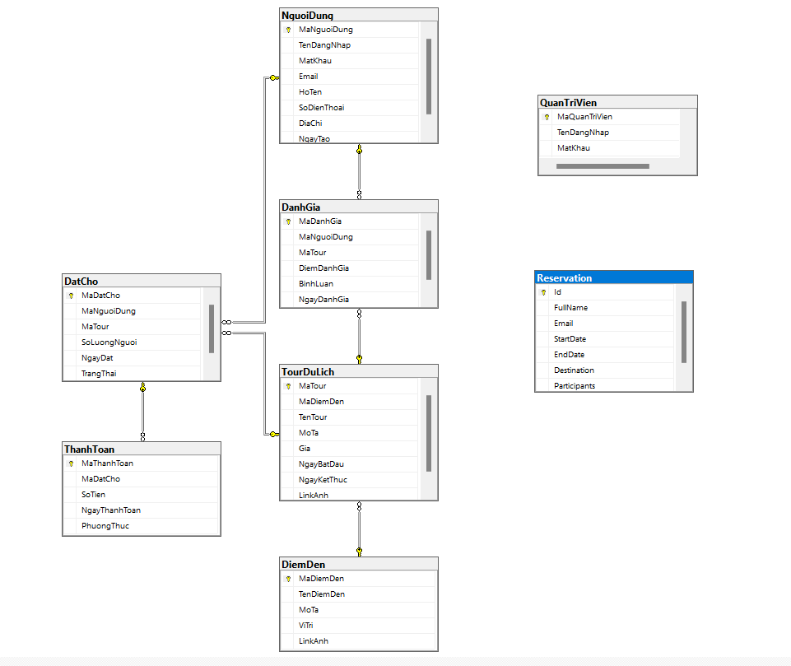

**2. User interface:**

- The "management" interface allows users to add, edit, delete, and update information

- The "Invoice" section interface allows users to create new invoices and view a list of existing invoices.

**3. Add, edit, delete and update functions:**

- The “Add” function allows users to add new records to the table, such as adding a new customer or a new invoice.

- The "Edit" function allows users to update information of existing records such as editing customer information and invoices.

- The "Delete" function allows users to delete a record that is no longer needed, such as deleting a customer or an invoice.

- The “Update” function allows users to update data after making changes, such as after editing customer information or adding items to an invoice.

**4. Search feature:**

- The search feature allows users to search records in tabular form like searching for information.

- Search results will display a list of records that match the search criteria.

- This travel website helps stores effectively provide information about customers, employees, invoices, and products. Add, edit, delete, update features along with search feature make data convenient and accurate.

# Build and test the system

## Program interface

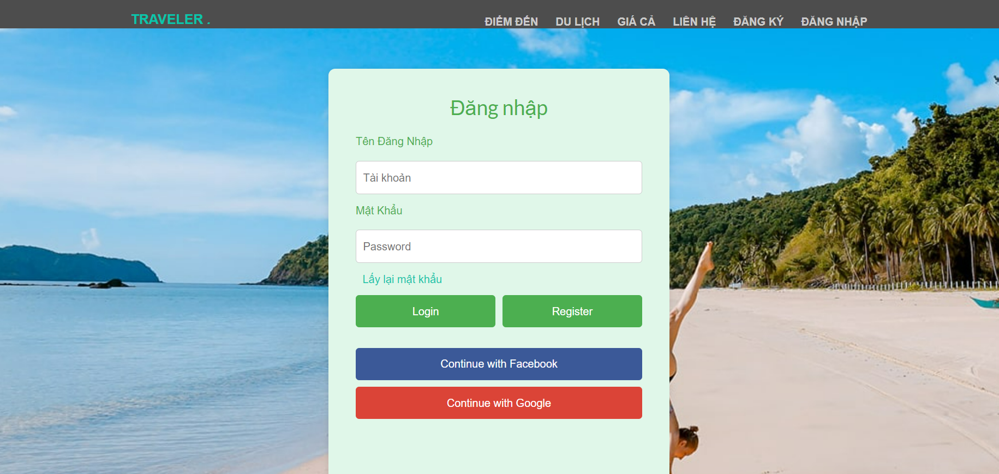

Figure 1: Login interface

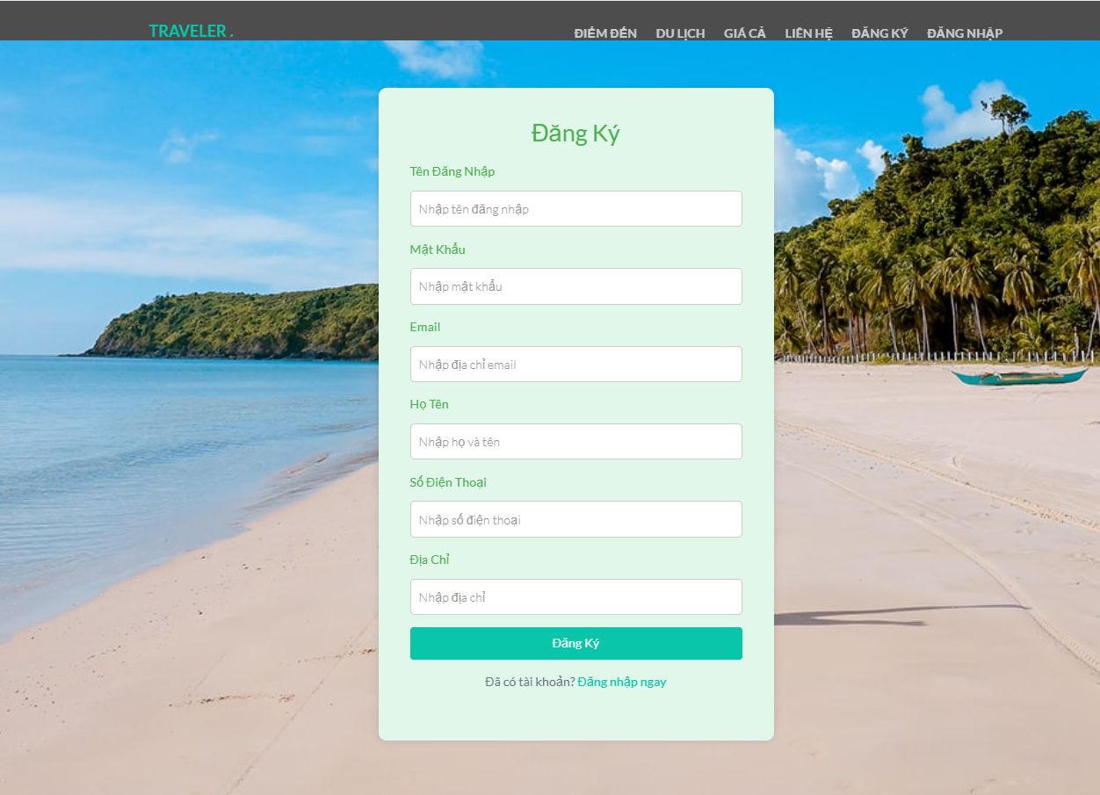

Figure 8: Registration interface

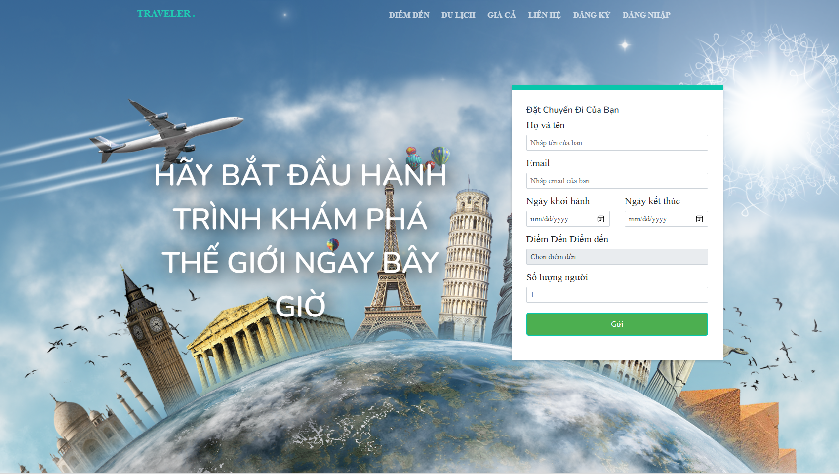

Figure 9: Home page interface

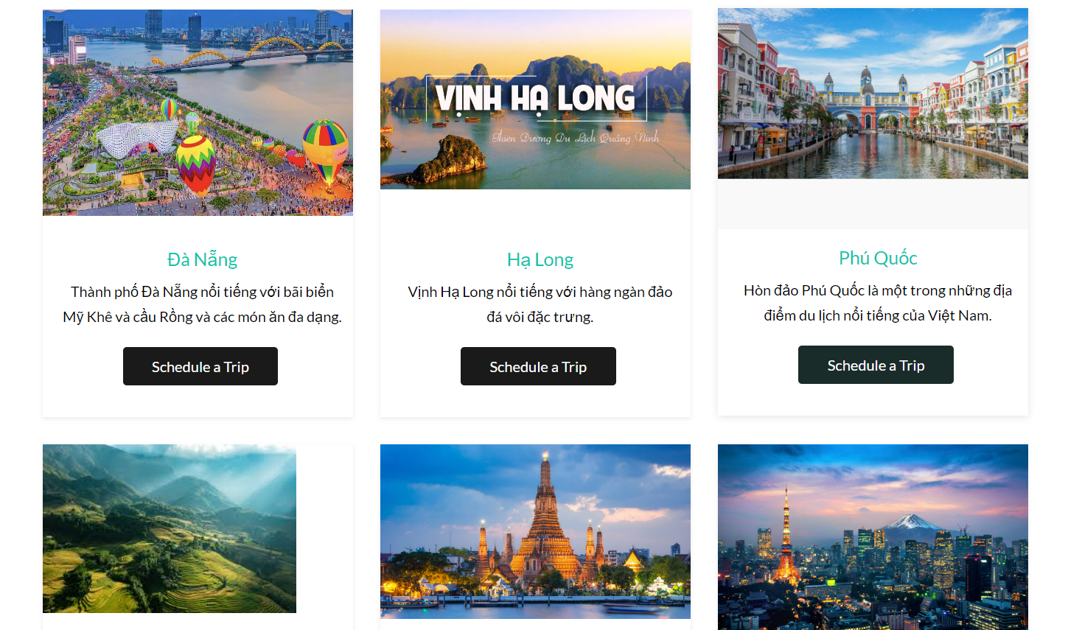

Figure 10: Destination interface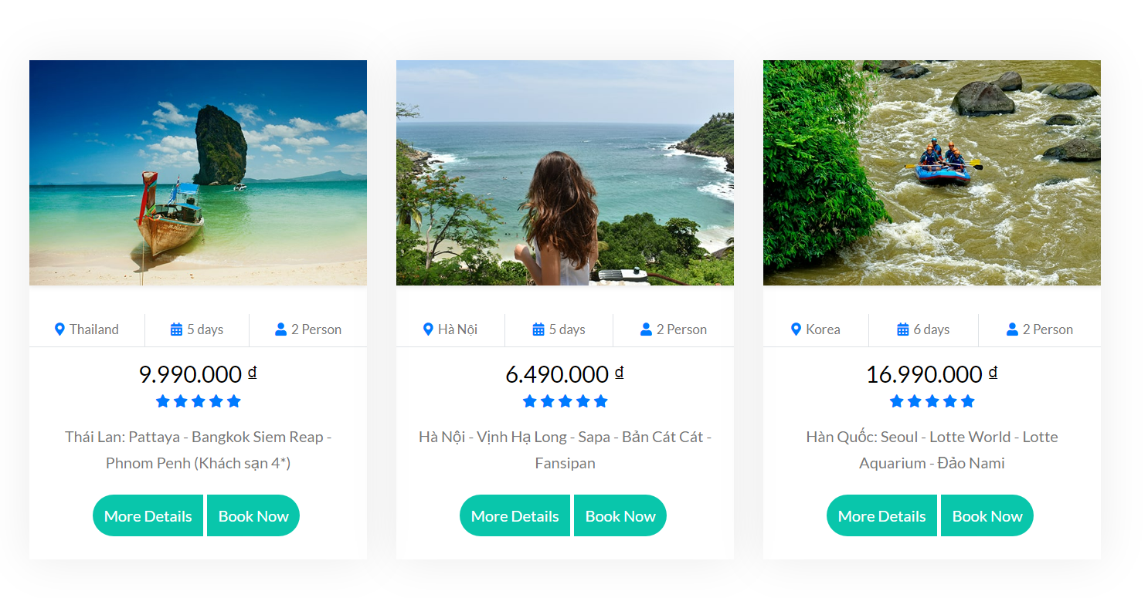

Figure 11: Pricing interface

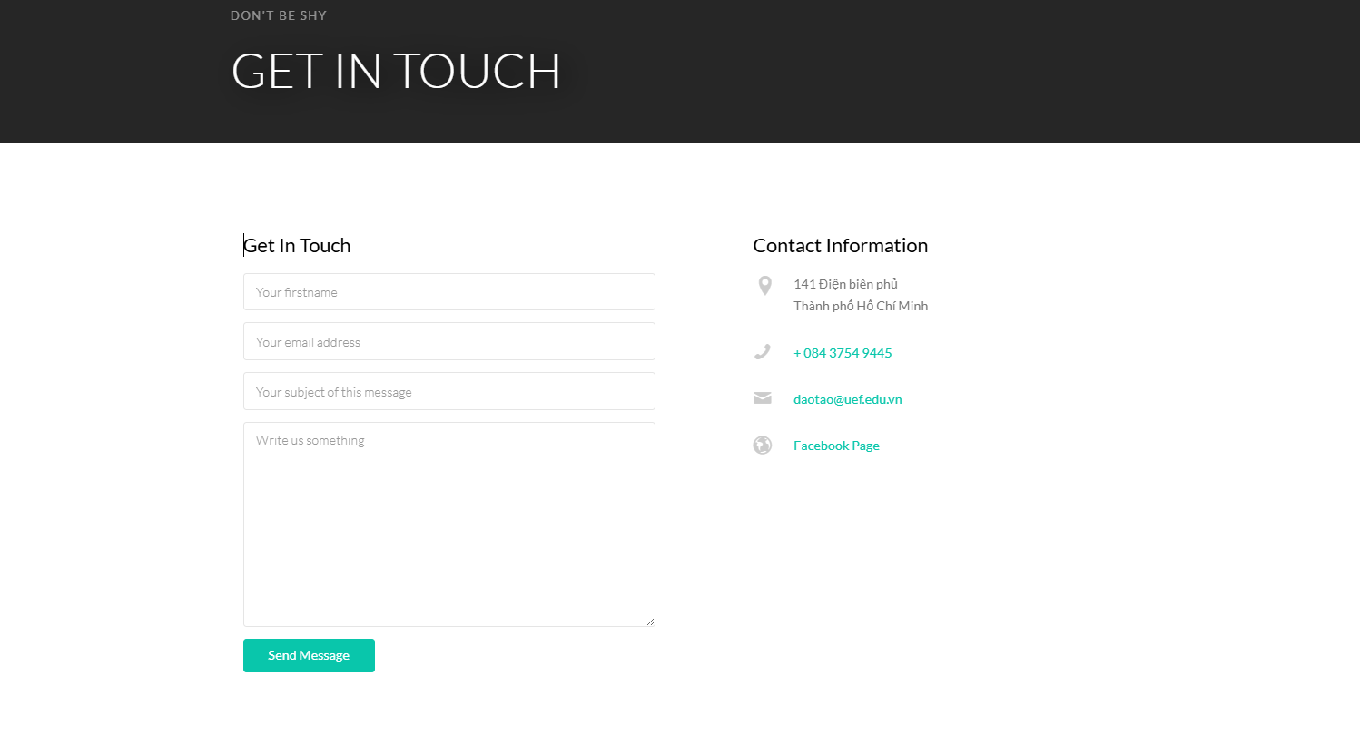

Figure 12: Contact interface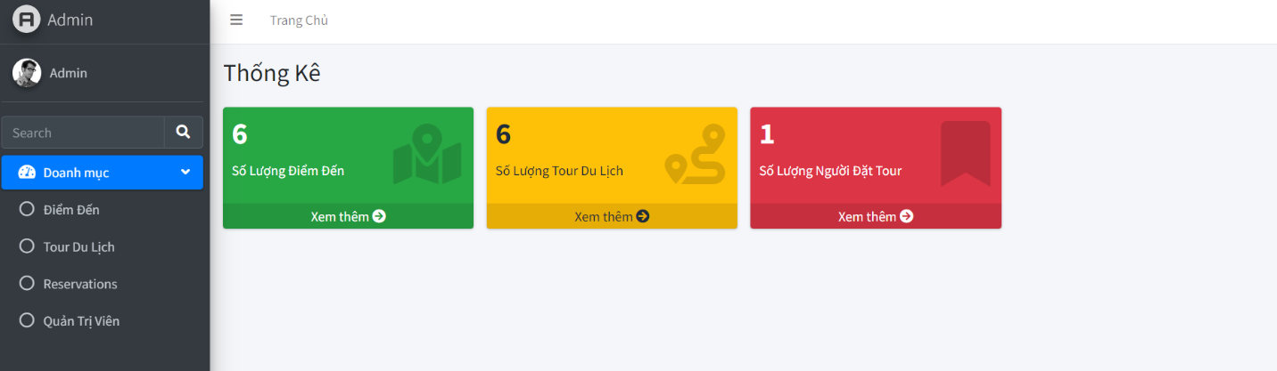

Figure 13: Admin home page interface

# Conclusion and development direction of the topic.

## Conclusion

The group wants to create a website that helps activities in tourism websites effectively. Through the research and development process, the team has achieved a number of important achievements. Design and develop the website interface based on user-friendly principles, helping store staff easily use the website without the need for in-depth professional knowledge. Database integration allows product, customer and transaction information to be securely stored and easily retrieved. The team has performed testing and bug fixes to ensure website stability and reliability.

## Development direction of the topic

Integrating artificial intelligence (AI): Using machine learning and artificial intelligence to analyze data and predict customer shopping trends.

Product recommendations based on customers' shopping history and shopping habits.

Online payment integration: Develop secure online payment integration that allows customers to pay directly through the app.

Supports popular payment gateways such as PayPal, Stripe or local payment gateways..

**Decentralization and security:**

Improved permissions for employee access by position and responsibility.

Enhanced security to protect important information from unauthorized access.

Integrated data analysis:

Use data analytics tools to review sales information, predict inventory needs, and optimize business strategies.

**Experience**

Enhanced customer interaction:

Develop promotional and customer care programs to create connections and increase loyalty.

Integrate customer feedback to improve products and services..

Cross-platform application development:

If necessary, develop a version of the application that can run on many different operating systems (Windows, macOS, Linux).

This development direction helps create a modern and diverse travel website application, meeting the needs of stores and customers in an increasingly competitive market.